SIGN LANGUAGE RECOGNITION SYSTEM BASED ON CONVOLUTIONAL NEURAL NETWORKS (CNNS)
Methodology, Novelty and Key Contributions
Department of Computer Science and Engineering, TKR College of Engineering & Technology
Batch A16 (CSE-A) · Academic year [ACADEMIC YEAR]
Table 1: Project team
S.No. | Student name | Roll number
1 | AJAY | 24K95A0502
2 | A NAVADEEP REDDDY | 23K91A0514
3 | B MANIDEEP | 23K91A0540
4 | B MAHESHWARI | 23K91A0536

Project guide: V. PALLAVI
Chapter and section numbers quoted in the text (for example Chapter 8 or Section 6.2) refer to the full project report, 17.Final Document. Figures and tables in this document are numbered from 1.

1. METHODOLOGY
This document describes how SignSpeak works from end to end and what is new in it. Part 1 gives the pipeline, the data, the algorithms and the reasons they were chosen; Part 2 sets the work against the base paper and separates what is new from what is standard; Part 3 lists the contributions.

1.1 Overall methodology
The method is an ordinary supervised image-classification pipeline, built so that the same code path serves three purposes. Hand images are cropped to a fixed region, reduced to a binary hand mask by classical image processing, resized to 64x64 and fed to a small convolutional network that outputs a probability for each of 29 classes: the 26 letters A-Z and three control signs (space, del, nothing). During live use a short temporal filter turns the stream of per-frame predictions into typed letters. The steps are:
1. Collect or import labelled hand images (own captures through the Collect screen, or the public Kaggle ASL Alphabet images).
2. Preprocess each image: ROI crop, grayscale, Gaussian blur, Otsu threshold, morphology, resize to 64x64, scale to [0, 1].
3. Split the images 70/15/15 into training, validation and test sets with a stratified split (seed 42).
4. Train the CNN with augmentation, the Adam optimiser and early stopping on validation accuracy.
5. Evaluate once on the held-out test split: accuracy, per-class precision/recall/F1, confusion matrix, threshold behaviour, robustness and latency.
6. Recognise live: send browser frames to the server, classify, apply the confidence threshold, vote over 15 frames and commit a letter after 18 stable frames.
7. Speak the finished sentence with an offline text-to-speech voice.
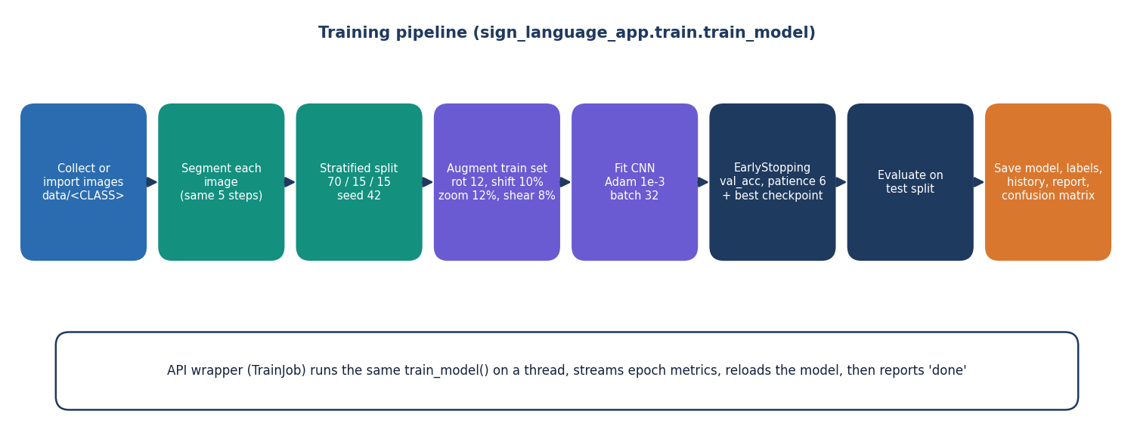
Figure 1: Training pipeline used for the saved model.

1.2 Dataset
The working dataset is a subset of the public Kaggle ASL Alphabet collection [25]. The archive on disk holds 87,000 training images (29 classes of 3,000 each, 200x200 colour JPEG) and 28 official test images (one per letter except del, plus space and nothing). A script (scripts/prepare_data.py) copies an evenly spaced subset of 250 images per class, 7,250 in all, into data/; on a CPU machine this keeps loading to 75 s and an epoch to about 9.9 s. The images are split with a stratified 70/15/15 split (seed 42) into 5,075 training, 1,087 validation and 1,088 test images (37-38 test images per class).
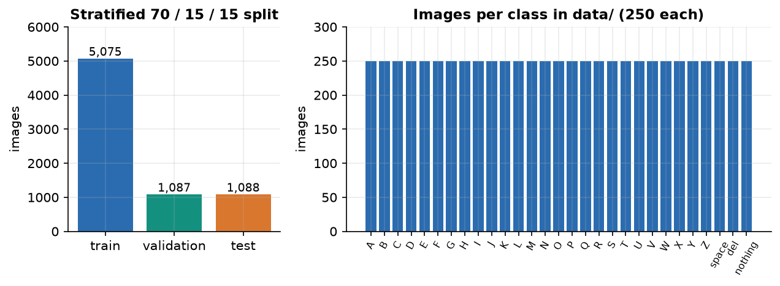
Figure 2: Class counts and the train/validation/test split.
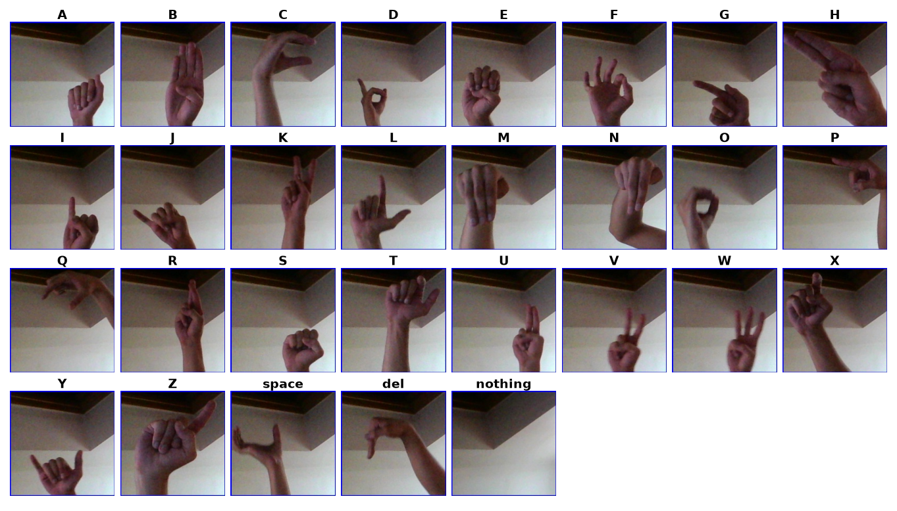
Figure 3: Sample images from the working dataset (one row of letters).
Two properties of the data decide how its results must be read. First, the images are frames cut from short videos of a few recordings, so neighbouring frames are near-duplicates; second, the archive carries no signer identifier. A random split therefore puts near-identical frames on both sides of the split, and the test accuracy measures how well the model reads held-out frames of the recorded signers and scenes, not how well it reads a new person in a new room. This is stated again wherever a number is quoted (Chapters 7 to 10). The archive does not bundle a licence file; its terms should be read on the dataset's Kaggle page before any redistribution, and the images are not redistributed with this submission.

1.3 Preprocessing
Preprocessing is one function (preprocess_roi) used by collection previews, training and live recognition, in the order given by the project abstract: region of interest, grayscale, noise reduction, segmentation, normalisation.
Table 2: Preprocessing steps and their reasons
Step | Operation (parameters) | Reason
1 ROI crop | 300x300 box at x 620-920, y 90-390 of the 960x540 frame | Fixed box on the right of the frame: the signer places the hand in it; background elsewhere is ignored.
2 Grayscale | BGR to gray | Hand shape, not colour, carries the letter; one channel is 3x cheaper.
3 Noise reduction | Gaussian blur 7x7 | Suppresses sensor noise and JPEG blocks before thresholding.
4 Segmentation | Otsu threshold; invert if the mask mean exceeds 127 | Chooses the threshold automatically per frame; the inversion keeps the hand as the bright region on bright and dark backgrounds.
5 Morphology | Opening x1, closing x2, 3x3 kernel | Removes specks and closes small holes in the silhouette.
6 Normalise | Resize to 64x64 (area interpolation), divide by 255 | Fixed small input; values in [0, 1] for stable training.

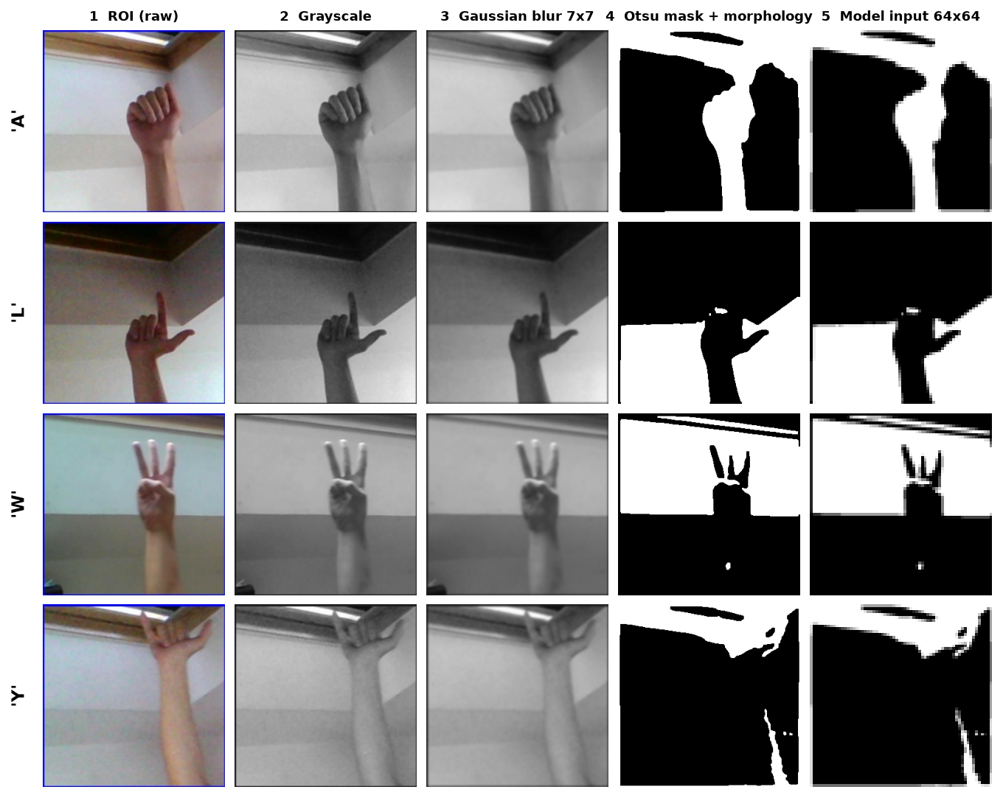
Figure 4: Preprocessing stages on real dataset images: colour crop, grayscale, blur, Otsu mask and the final 64x64 input.
The figure also shows the method's main weakness. Otsu's method finds the best single grey-level threshold, not the hand; where the background has structure of a similar brightness the mask contains background shapes next to the hand. The network can therefore partly learn the scene of the training recordings, which is one reason why the held-out accuracy of Chapter 8 should not be read as accuracy for a new user. A skin-colour mask (segment_skin, YCrCb) exists in the code as an alternative; it was not evaluated and the default is Otsu.

1.4 Algorithm choice and justification
Why a CNN. A convolutional network learns local shape features (edges, finger contours) and combines them hierarchically with far fewer parameters than a fully connected network on the same pixels [7], [8]. For a 64x64 binary mask this needs only three convolution blocks, which trains in about ten seconds per epoch on a CPU and answers in about 50 ms per frame.
Why a binary mask instead of the colour image. The mask removes skin tone, clothing and most lighting differences, so a small network and a small dataset suffice. The cost is that errors of the segmentation step reach the network unchanged.
Why not skeleton or landmark input. The base paper [1] works on 2D skeletons from a pose estimator (such as MediaPipe [13]) and a graph convolutional network, which is robust to background and suits moving word signs. It needs a pose-estimation stage in front of the classifier and, for its distillation, labels for a mask and several teacher models. For static fingerspelling letters on a CPU the direct image route is simpler and its 50 ms latency leaves no need for a second network; we did not test a landmark-based alternative, so we make no claim about which is more accurate.
Why batch normalisation, dropout and augmentation. Batch normalisation [19] stabilises training of the deeper layers; dropout [20] (0.25 after blocks 2 and 3, 0.4 before the output) limits over-fitting of the 2.1-million-weight dense layer; random rotation, shift, zoom and shear [22] stand in for the variety that a small dataset lacks.
Why a temporal filter. A single frame is noisy: the hand moves between letters and individual frames are misread. Thresholding the confidence (0.75), taking the majority of the last 15 predictions and requiring 18 consecutive stable frames before typing a letter converts noisy frame-level output into deliberate keystrokes, at the price of a short delay (about a second at the measured frame rate).

1.5 Mathematical formulation
For an input mask x of size 64x64, a convolution layer with kernels w and bias b computes, for output channel k at position (i, j):
y[i,j,k] = ReLU( b_k + Σ_c Σ_u Σ_v w[u,v,c,k] · x[i+u, j+v, c] ), ReLU(z) = max(0, z) (1)
Batch normalisation [19] rescales each channel over a mini-batch with mean μ_B and variance σ_B², then applies a learned scale γ and shift β:
x̂ = (x − μ_B) / √(σ_B² + ε), y = γ · x̂ + β (2)
The last layer turns the 29 logits z into probabilities, and the network is trained to minimise the categorical cross-entropy over N training images with one-hot targets t:
p_k = exp(z_k) / Σ_j exp(z_j) (3)
L = − (1/N) Σ_n Σ_k t[n,k] · log p[n,k] (4)
The Adam optimiser [21] keeps running averages of the gradient g and its square and updates the weights θ with learning rate α = 10⁻³ (Keras defaults β₁ = 0.9, β₂ = 0.999):
m_t = β₁ m_{t−1} + (1−β₁) g_t, v_t = β₂ v_{t−1} + (1−β₂) g_t², θ_t = θ_{t−1} − α · m̂_t / (√v̂_t + ε) (5)
The segmentation step uses Otsu's criterion [17]: the threshold t* that maximises the between-class variance of the grey-level histogram, with class weights ω₀, ω₁ and means μ₀, μ₁ of the pixels below and above t:
σ_B²(t) = ω₀(t) · ω₁(t) · [μ₀(t) − μ₁(t)]², t* = argmax_t σ_B²(t) (6)
The decision rule of the recogniser is as follows. With τ = 0.75 the accepted label of frame t is a_t = argmax_k p_k if max_k p_k ≥ τ, and nothing otherwise. The smoothed label m_t is the most frequent of the last 15 accepted labels. If m_t has been the same for s consecutive frames, the letter m_t is committed when s ≥ 18, m_t ≠ nothing and m_t differs from the last committed letter; a smoothed label of nothing clears the last committed letter. Evaluation uses accuracy, precision P = TP/(TP+FP), recall R = TP/(TP+FN), F1 = 2PR/(P+R) per class, their unweighted mean (macro F1) and top-3 accuracy (the true class among the three most probable).

1.6 Model architecture and training
The architecture (Chapter 5, with its layer table) has 2,199,453 parameters and a 26.48 MB model file. The table below lists the training configuration. The saved model was trained for 30 epochs (the interface default is 25); the best validation accuracy, 84.7%, was reached at the last epoch, so the run ended because it hit its epoch cap, not because early stopping fired, and accuracy was still slowly rising.
Table 3: Training configuration
Setting | Value
Optimiser / loss | Adam, learning rate 1e-3 / categorical cross-entropy
Batch size / steps per epoch | 32 / 158 (5,075 training images // 32)
Epochs | 30 in the saved run (default 25, allowed 1-500)
Split | 70 / 15 / 15 stratified, seed 42
Augmentation (training only) | rotation 12 deg, width/height shift 10 %, zoom 12 %, shear 8 %, nearest fill
Early stopping | monitor validation accuracy, patience 6, restore best weights
Checkpoint | best validation accuracy kept in models/asl_cnn_model.keras
Hardware | 12th Gen Intel Core i5-12500 (6 cores / 12 threads), 15.7 GB RAM, no GPU; about 9.9 s per epoch (2-epoch benchmark)
Software | Python 3.11.9, TensorFlow 2.15.0, OpenCV 4.11.0, NumPy 1.26.4

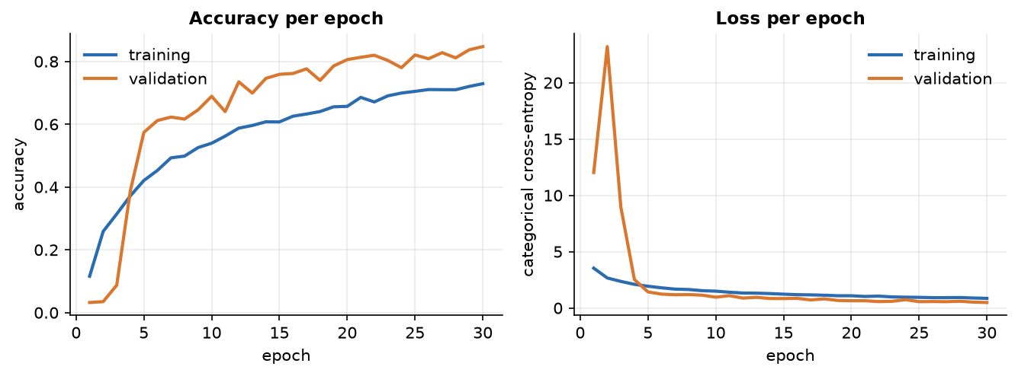
Figure 5: Training and validation accuracy and loss over the 30 epochs of the saved run.
The curves show training accuracy (72.9% at the end) below validation accuracy (84.7%). That is expected here: dropout and augmentation act only on the training pass, so the training figures are measured on harder inputs. The validation loss spikes in the first epochs (BatchNorm statistics are still warming up) and settles by epoch 6. The wall-clock time of the 30-epoch run itself was not recorded; the per-epoch figure comes from a separate 2-epoch benchmark on the same machine.

2. NOVELTY AGAINST THE BASE PAPER
SignSpeak does not propose a new learning algorithm, and we do not claim one. Its building blocks (convolution, batch normalisation, dropout, Adam, Otsu thresholding, majority voting) are standard. What is new is the combination, the way it is delivered and the care with which it is measured. This section states the difference from the base paper first and then lists what is, and is not, new.

2.1 Difference from the base paper
Table 4: SignSpeak and the base paper compared
Dimension | Base paper (MAG-KD) [1] | SignSpeak | What differs
Problem | Compress a skeleton-based sign recogniser for edge devices | Read fingerspelling letters live and turn them into text and speech | Different task: SignSpeak is an end-to-end assistive tool for letters
Input | 2D skeleton sequences from a pose estimator | Binary hand mask of a fixed region of a single frame | No pose estimator, no temporal model; classical segmentation
Core technique | Multi-teacher knowledge distillation with a hard correctness mask and an adaptive gate | A small CNN trained directly | No distillation; the base paper's central idea is not used
Evaluation | AUTSL and WLASL-100, three seeds, Jetson Nano profiling | Held-out split of 7,250 images, one seed, CPU latency | Much weaker statistics; no unseen-signer test
Deliverable | A training method and an edge-deployment study | A running application with collection, training, recognition and speech | SignSpeak adds the usable system around the model

The batch documents describe the project as reusing the base paper's technique. In fairness to the paper, we state what was actually taken from it: its motivation (real-time sign recognition on modest hardware, as a communication aid) and its attention to measured speed. Its method was not reproduced, because it addresses a different input (skeleton sequences) and a different problem (word signs in video).

2.2 What is standard and what is new
Table 5: Standard components and project-specific elements
Element | Standard or new | Comment
Convolution + batch norm + dropout + Adam | Standard | Textbook components [7], [19], [20], [21]
Otsu threshold, morphology | Standard | Classical segmentation [17], [18]
Shared preprocessing for collection, training and live use | Design choice | Removes train/serve mismatch
Confidence gate + 15-frame vote + 18-frame stability + repeat guard | Project-specific | Turns noisy frame labels into typed letters; its trade-off is measured (Chapter 8)
Browser-owned camera with a cover-crop/mirror/JPEG protocol and a one-request-at-a-time loop | Project-specific | Gives the server a frame whose ROI matches the box drawn on screen; bounds the load
Web and desktop front ends over one set of modules | Project-specific | The API contains no model logic; both interfaces use the same code
In-application collect, train and report loop | Project-specific | A user can build a personal model without leaving the browser
Honest evaluation: near-duplicate analysis, threshold curve, robustness, latency, test suite | Project-specific | States which numbers are optimistic and which are headline

3. KEY CONTRIBUTIONS
The key contributions, in the order in which the evidence supports them, are:
1. An end-to-end ASL fingerspelling system - camera, segmentation, CNN, temporal decision logic, sentence builder and speech - delivered as a desktop and a web application that share one code path.
2. A measured baseline. A 2.20-million-parameter CNN reaches 82.81% accuracy, macro F1 0.830 and top-3 accuracy 92.9% on a held-out split of 1,088 images, with per-class results and the most frequent confusions.
3. A quantified decision rule. At the 0.75 confidence threshold, 70.3% of frames are accepted and 97.1% of them are correct; the full curve is reported.
4. Real-time evidence on a CPU. 52.9 ms per frame on the server and 56.7 ms over HTTP (about 17.6 frames per second), with the stage-by-stage breakdown.
5. A frank evaluation. Robustness to brightness, noise, blur and rotation; an explanation of why the dataset's near-duplicate frames inflate some numbers; objectives reported as met, partly met or not met.
6. Engineering quality. 52 automated tests, a 26-check end-to-end smoke test, a measurement script that regenerates every reported number, and a verifier for the documentation.

